Stock analyze report

* Business statement:

The price of oil is sensitive, which implied the real economy perform. Figure 1 shows the New York crude oil price from 2009 year to 2019 year. As can be seen, the price went down sharply in 2014 year. According the figure, the price of oil are steadily rising from 2016 year. It means the economic is positive in the future.

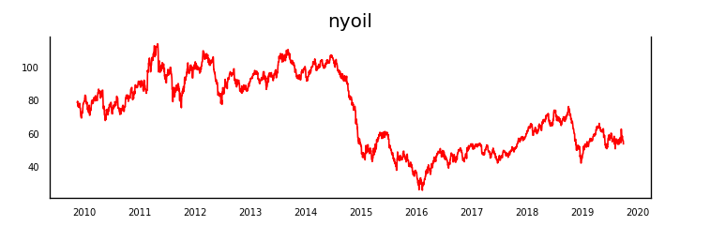

Figure 1: the New York Crude Oil Price

Russia is one of oil producing country, which is the second higher oil supplier country. The RSTI would be affected by the price of oil. There are many oil-relation stocks that would be affected by oil. Hence, Could the XOP and RSTI be our next investment target?

* Data understanding
* Data Resource:

NY crude oil prices: <https://www.eia.gov/dnav/pet/hist/RCLC1D.htm>

10 Year Treasury Rate-54 year Historical Chart: <https://www.macrotrends.net>

RTSI: <http://www.investing.com>

Consumer price index: <https://beta.bls.gov/dataViewer/view/timeseries/CUUR0000SA0>

Gold: <https://www.macrotrends.net/1333/historical-gold-prices-100-year-chart>

Monetary base: <https://fred.stlouisfed.org/series/BOGMBASEW>

* Variable correlation(Pearson correlation):

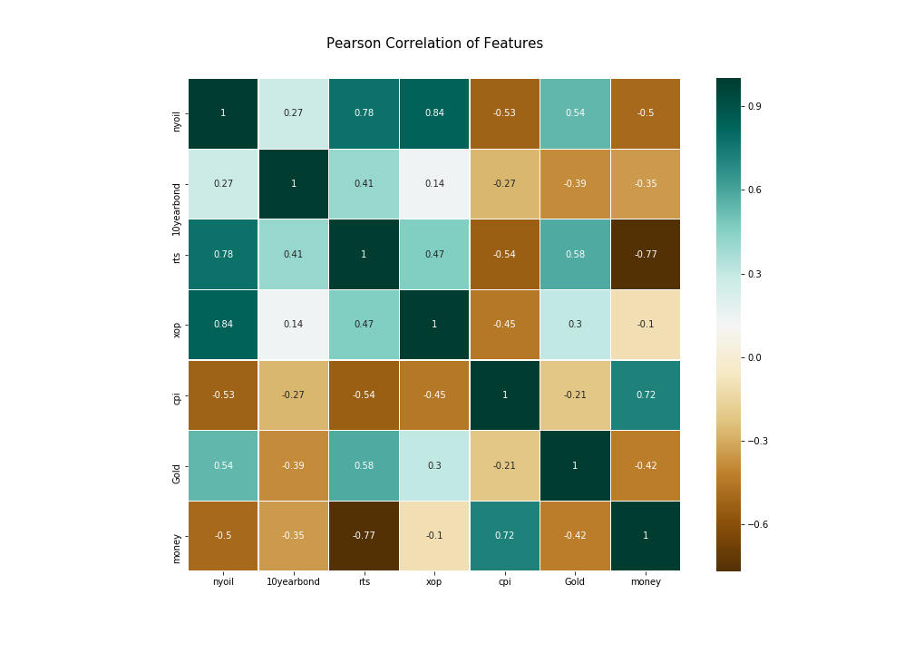

Obviously, the price of oil have strongly relationship with XOP and RTSI. They have positive relationship. However, there are many relationships of the oil and other variable, which affects the price of oil. Hence, let’s take a look.

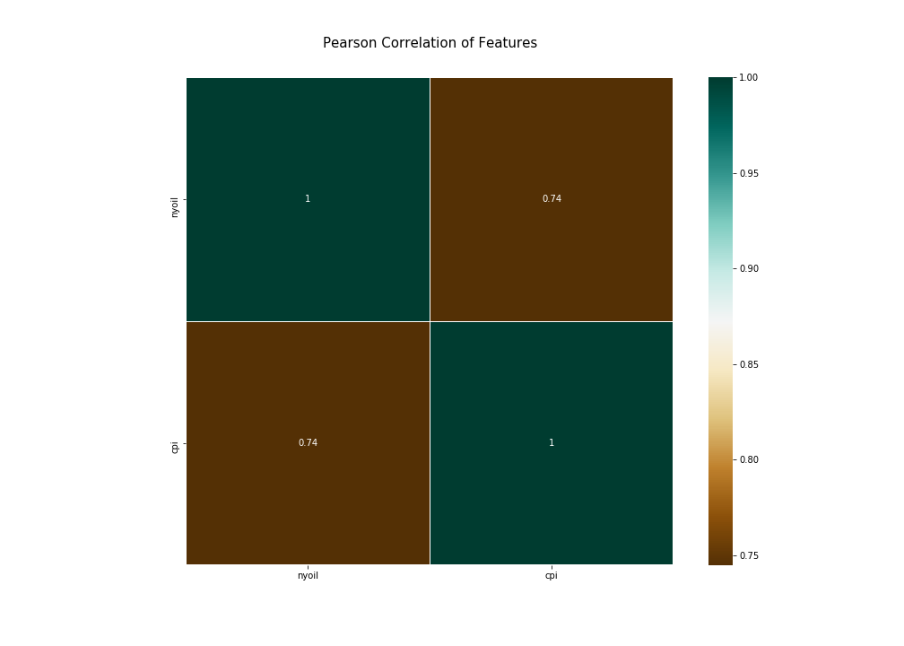

First, the relationship of oil and customer price index. It is so surprise that the price of oil and customer price index have the negative relationship. From the long term, the price of oil would cause the inflation that mean the customer price index would went up. However, in the short term, especially in last 10 years, I think the real economic, GDP, is not good enough. Even the price of oil have increase slowly, the customer price index is not obviously increase.

Even we understand the connection of oil and CPI, we need to go to the next step to discuss the relationship of customer price index and monetary base. According these figures, we can see the government control the inflation rate by using the monetary policy, such as issue the money. The CPI and the monetary base have the positive relationship. In the past, the productivity cannot afford the amount of population, which cause the inflation. The government need to issue the money to slow down the inflation. Recently, the technology still break through that make the productivity is higher. The higher productivity can afford the amount of population, and the supply is higher than the demand that make deflation. The government won’t let the economic went down, so using the monetary policy to control the CPI.

Second, the relationship of oil and gold. As can be seen, the oil and gold is positive relationship. Increasing the price of Oil means the real economic would be positive, which cause the inflation. The inflation implies the money is not worth then before. At the time, people want to buy the Gold to maintain their profit. When the price of oil increase, the Gold maybe is another investment target.

* Causality test:

We use the Granger Causality test to figure out the causality relationship. From the variable correlation, we can realize the relationship of two variable, but we cannot know what variable cause the other variable. According the table, we can have the whole story about the fluctuation of XOP and RTSI.

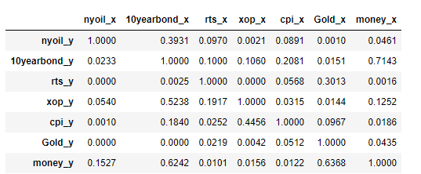

The table displays the causality relationship between two variable. As can be seen, the oil causes the CPI and then cause the monetary base. According to the table, we can see the monetary base cause the Gold. The price of oil is the raw materials of industry, so the volatility of oil price affects the price of product easily. When the inflation occurs, the government can control inflation by using monetary policy. The inflation implies the money is not worth then before. At the time, people want to buy the Gold to maintain their profit.

We can imagine that the impact is bilateral. The customer price index causes the government want to use monetary. After the government handle, the customer price index would change. Recently, States use QE policy that control the deflation situation after 2008 financial crisis.

So far, we can say the oil cause CPI and then causing monetary base. Obviously, the government also can have monetary policy cause CPI, that would affect the oil. From this point, we can observe the price of oil and the government monetary policy to predict the XOP and RTSI.

* Modeling
* Moving Average

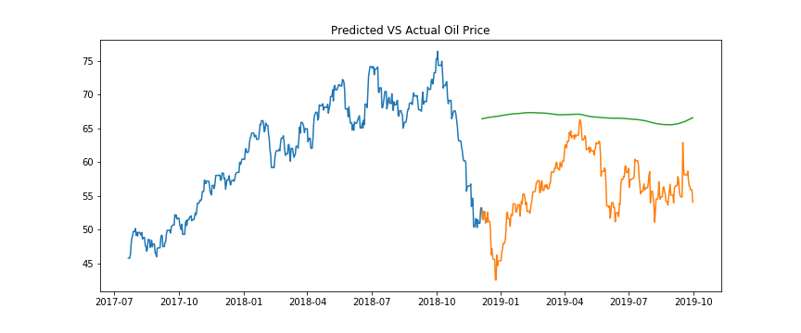

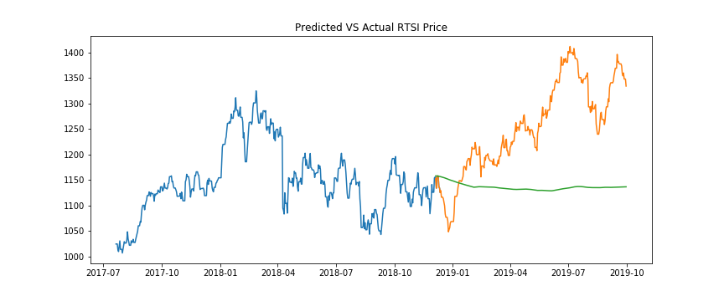

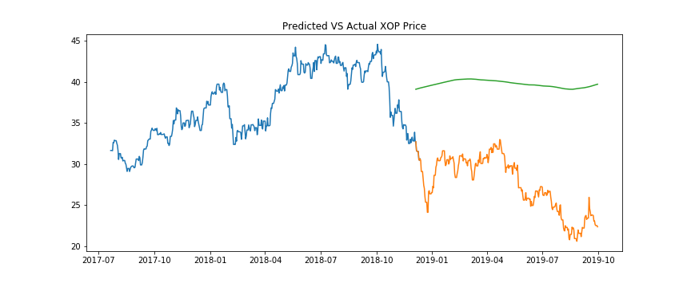

* Linear regression

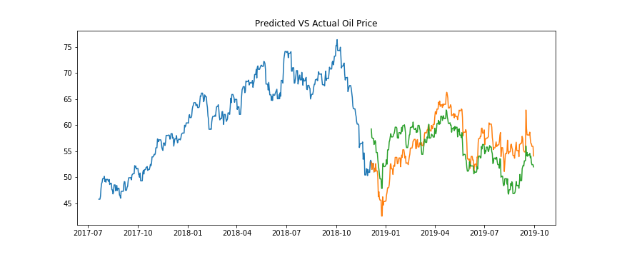

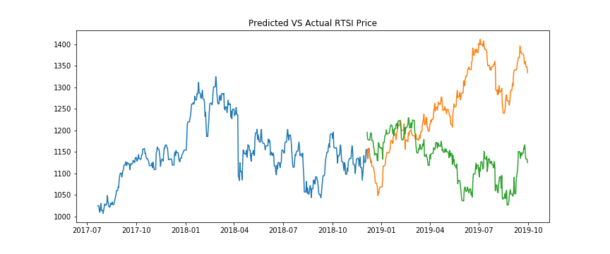

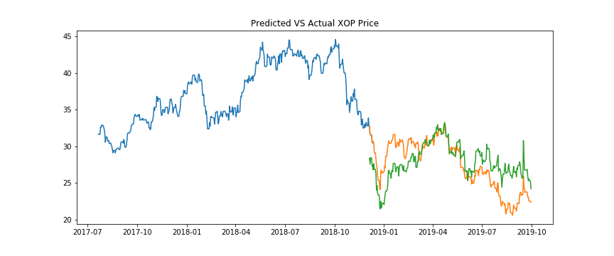

* VAR model

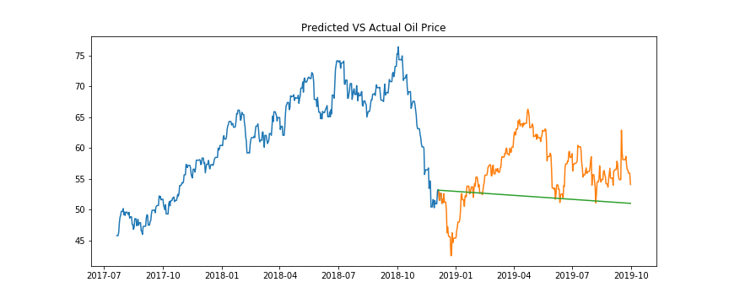

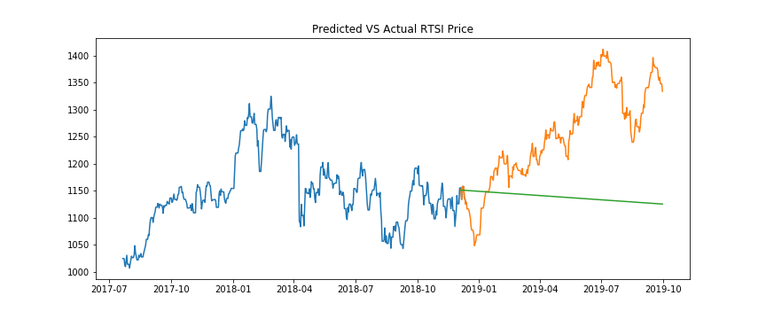

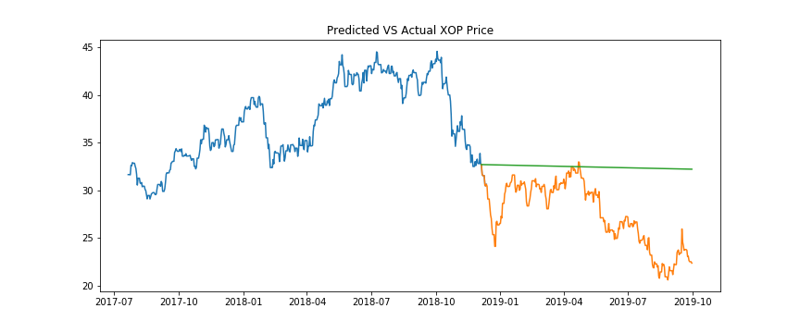

* Evaluation
* Conclusion